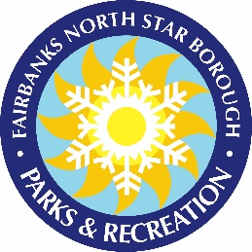
WESCOTT POOL SWIM LESSON SCHEDULE
(907) 488-9402
300 E 8TH Ave, North Pole, AK 99705

February 2024

TUESDAY/THURSDAY
Session Dates Costs (30min/45min) Registration No class
Feb 6-29 $56.00/$63.00 Jan 30 7a Feb 20th

Preschool 5:00-5:30p, 5:35-6:05p
Level 1/2 5:00-5:45p, 6:00-6:45p
Level 3 6:10-6:55p

WEDNESDAYS
Session Dates Costs (30min/45min) Registration No class
Feb 7-28 $32.00/$36.00 Jan 31 7a

Preschool 5:00-5:30p 5:35-6:05p
Level 1/2 6:00-6:45p
Level 4 5:00-5:45p

SATURDAYS
Session Dates Costs (30min/45min) Registration No class
Feb 3-24 $32.00/$36.00 Jan 25 7a

Preschool 10:00-10:30a, 10:35-11:05a
Level 1/2 10:00-10:45a, 11:00-11:45a
Level 3 11:00-11:45a

REGISTRATION LIMITED TO ONE CLASS SESSION PER STUDENT DUE TO LIMITED AVAILABILITY.

Registration opens on the date and time listed above. Classes are open until filled but will close after the first day of class.

Class schedule is subject to change. Please call, 488-9402, for information on swim lessons and registration.

To register, visit our website at PARKS.FNSB.GOV.
Like us on Facebook! Fairbanks North Star Borough Parks & Recreation

